BUS 440 Project 1
Fall 2026
Name: Gania Tyagi

Use Case:
Suppose you are hired to create a database for the hypothetical Laykin Consulting Firm to track their sales of services to companies. Their services include training, consulting, and development in various domains including market research, compensation, and strategy, along with software development capabilities in programming languages of Java, Python, SQL, Scala, PHP, and .NET along with general capabilities related to technologies related to Big Data, Database, business logic, business modeling, and Front-End Web services.
The company hires consultants to perform these services (called products internally) to a company in an industry. Each consultant is placed on a project (under the direction of a manager) and billed out at an hourly wage. Each consultant’s wage margin on each order is also tracked.
A quote is given to each customer on an order, representing the quantity (units) x rate of an order line item. For example, Matt Miller from PACCAR Inc. ordered 6 units of business modeling consulting from Laykin Consulting Firm at a rate of $150 each, resulting in a quote of $900. Sometimes, Laykin offers a discount percentage to the customer, and the sale amount reflects that applied discount, though not exactly.
The data are tracked in a spreadsheet currently, but there are problems with redundancy, missing data, and errors in the data. In this project, you will design and build a relational database to hold data about the order transactions of these products to their customers. The database should track data about consultants, managers, companies, services, regions, and other needed perspectives.
Instructions:
- Download and open the .csv file with the hypothetical Laykin Consulting Firm data on Moodle. Though these data represent a sample of the past order transactions from 2025, your database will eventually contain data from multiple years.

- Scrutinize the data. Find and correct any missing or erroneous data. Note that some zip codes are incorrect and some products have missing data. List any corrections you made below.

I filled in the blank from row 176 under the product column to “Training – Python” because its product category was training and its subcategory was python.

I also changed the cells that had MO and MA as Missouri and Massachusetts

I also changed the city to match the zipcode because the zipcode 15122 matches with Pittsburgh not west Mifflin in Pennsylvania

- Write the business rules for the use case below.

Each customer works for one company exactly
A sector can be used for multiple industries
There are 3 types of services (three product categories) – development, training, consulting
Each consultant can work on more than one product subcategory
Each consultant has exactly one hourly wage
There is at least one manager that serves in each region
A consultant can have more than one manager
Consultant can have multiple wage margins
One order can contain two different sub product categories
There are 17 types of sub products
A order has one order date even if it has two different sub product categories
Orders can have 0 or more % discount rate

- Write the functional dependencies below.

Product -> product category
Row id -> quantity, quote, rate, discount
Consultant - > hourly wage
Order id -> order date, customer name
Company name -> sector, industry
State -> region
Customername ->companyname
Rowid -> order id

- Consider the themes, and then type one relational schema (with all of the spreadsheet attributes (column headings)) based on the metadata of those themes.

Orderline(RowID, OrderID, OrderDate, Quantity, Quote, DiscountPct, Rate, SaleAmount, CustomerName, CompanyName, Sector, Industry, City, ZipCode, State, Region, Product, ProductCategory, ProductSubCategory, Consultant, HourlyWage, Manager, WageMargin)

- For the relational schema above, normalize your data architecture to 3NF. Show your work for each step (1NF, 2NF, and 3NF) below. Do not use any surrogate PKs in this step.
1NF: Find the PK. Underline and bold it.
ORDERLINE(RowID, OrderID, OrderDate, Quantity, Quote, DiscountPct, Rate, SaleAmount, CustomerName, CompanyName, Sector, Industry, City, ZipCode, State, Region, Product, ProductCategory, ProductSubCategory, Consultant, HourlyWage, Manager, WageMargin)
2NF: Remove any partial dependencies.
ORDERLINE (RowID, OrderID, OrderDate, Quantity, Quote, DiscountPct, Rate, SaleAmount, CustomerName, CompanyName, Sector, Industry, City, ZipCode, State, Region, Product, ProductCategory, ProductSubCategory, Consultant, HourlyWage, Manager, WageMargin)

3NF: Remove transitive dependencies.
ORDERLINE (RowID, OrderID, Quantity, Quote, DiscountPct, Rate, SaleAmount, Product, ProductSubCategory, Consultant, WageMargin, Manager, City, ZipCode, State)
ORDERS(OrderID, OrderDate, Customer name, CompanyName)
LOCATION(State, Region)
COMPANY(CompanyName, Sector, Industry)
PRODUCT(Product, ProductCategory)
CONSULTANT(Consultant, HourlyWage)
- Copy your answer from 3NF and paste below. Then, add at least two improvements to the architectural design and show these improvements in the relational schema.
ORDERLINE (RowID, OrderID, Quantity, Quote, DiscountPct, Rate, SaleAmount, ProductSubCategory, WageMargin, Manager, City, ZipCode, CompanyID, ProductID, ConsultantID, StateID)
ORDERS(OrderID, OrderDate, Customer name, CompanyName)
LOCATION(StateID, State, Region)
COMPANY(CompanyID, CompanyName, Sector, Industry)
PRODUCT(ProductID, Product, ProductCategory)
CONSULTANT(ConsultantID, Consultant, HourlyWage)
I created ids for the tables

- Launch MySQL Workbench and create the EER for the architectural design of the database using MySQL Workbench. Be sure to include all entities, relationships, keys, and cardinality. Create the appropriate type of relationship, either identifying (solid line) or non-identifying (dashed line) based on your keys. Name the design LaykinOrderYourName, (where YourName is your last name). Note: you are required to include the .mwb file (which contains your EER) in your submission.

- Exit out of the design part of MySQL Workbench. Click the Home icon and sign back into the build part. Create a new schema, named LaykinOrderYourName, (where YourName is your last name).

- Open a new .sql script and save it as Project1YourName (where your name is your last name).

- Populate the spreadsheet data for the orderdetails table using Mr. Data Converter. To do so, complete the following steps:
- Navigate to Mr. Data Converter
- Change the bottom Output as: panel to MySQL.
- Copy the data from Excel and paste it into the top panel.
- Select the code in the bottom panel, copy the code, and paste it into a new query tab in MySQL Workbench.
- In MySQL Workbench, change the table name to orderdetails in the script in both the CREATE TABLE code and INSERT INTO code. If needed, enclose any text-based values in the code with tickmarks.
- At the top of your script, type and run the use statement for your new schema.
- Run the remainder of the code in the script. Be sure all 191 rows of data were created.

- Build each remaining table in your architectural design with SQL code. Be sure to include the PK. Start with the parent tables first. For example, here is the code to create the company table from a sample architectural design that includes a surrogate PK as an improvement:
CREATE TABLE company (
companyid int auto_increment,
companyname varchar(50) not null,
industry varchar(80) not null,
created_at TIMESTAMP DEFAULT CURRENT_TIMESTAMP,
PRIMARY KEY (companyid)
);

- To insert data into the other tables in your architectural design, write SQL code using SELECT DISTINCT to populate the parent tables from your design with data. The “generic” syntax for this code is below. Once the parent tables have data, run additional code to populate the child tables.
INSERT INTO target_table (column1, column2, ...)
SELECT DISTINCT column1, column2, ...
FROM source_table;
Here is an example of code to insert data into the company table:
INSERT INTO company (companyname, industry)
SELECT DISTINCT companyname, industry
FROM orderdetails;

Here is an example of code to insert data into the order table:
insert into laykinorderfowler.order (OrderID, OrderDate, Customerid)
SELECT DISTINCT orderid, orderdate,
(select customerid from customer where customer.customername = orderproduct.customername)
FROM orderdetails;

14. Create any needed FKs. Here is an example of code to create a foreign key in the order table for the customerid (a surrogate PK added in the Improvements process):
ALTER TABLE laykinorderfowler.order
ADD CONSTRAINT order_cust_FK FOREIGN KEY(Customerid)
REFERENCES Customer(Customerid);

Here is the screenshots of tables being created:
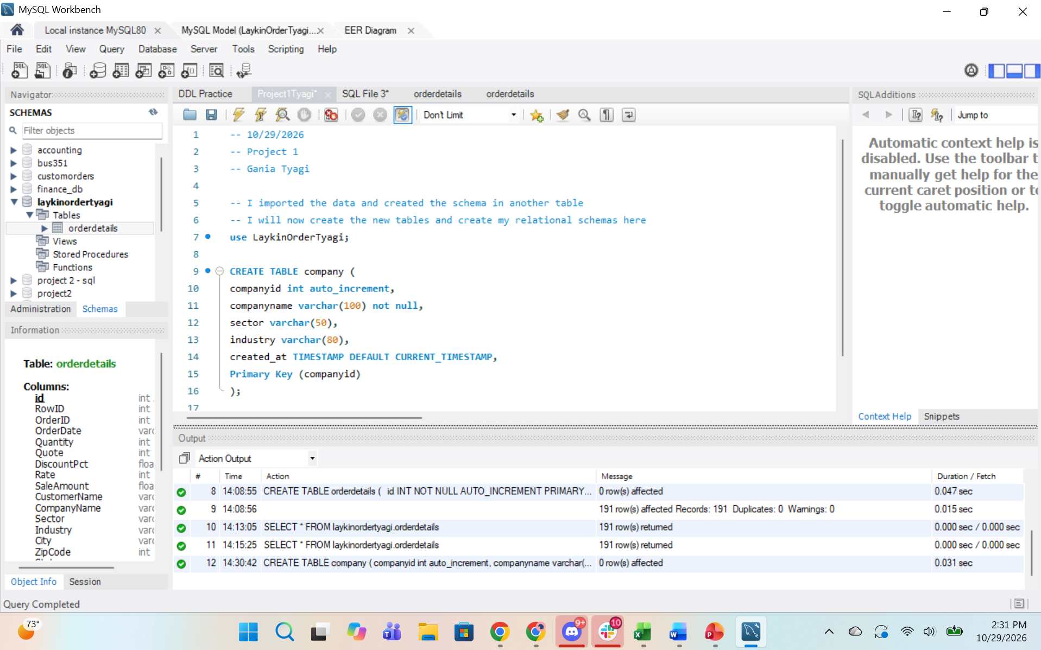
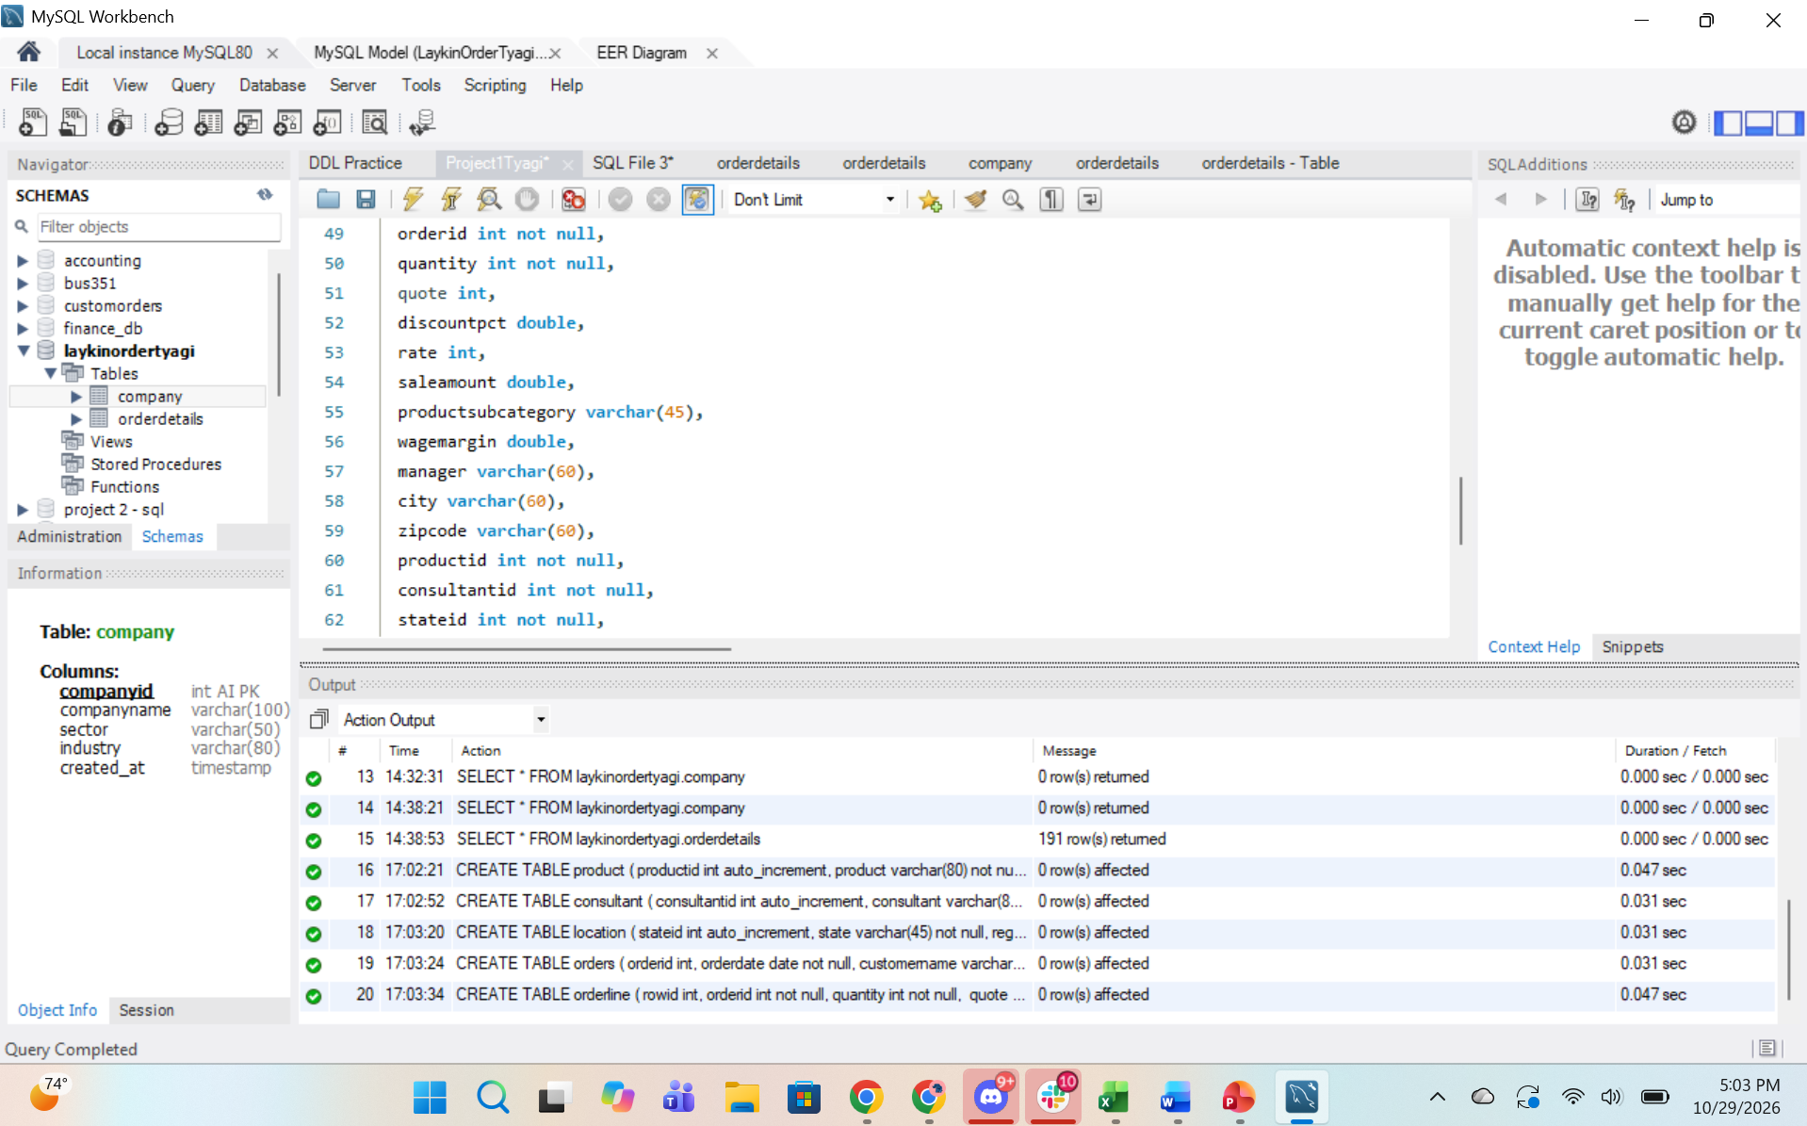

15. Once all tables are successfully created, drop the unnecessary columns from the orderproduct table.

16. Write and execute SQL code to print out the data from each table. Screenshot your code and results.
Company: 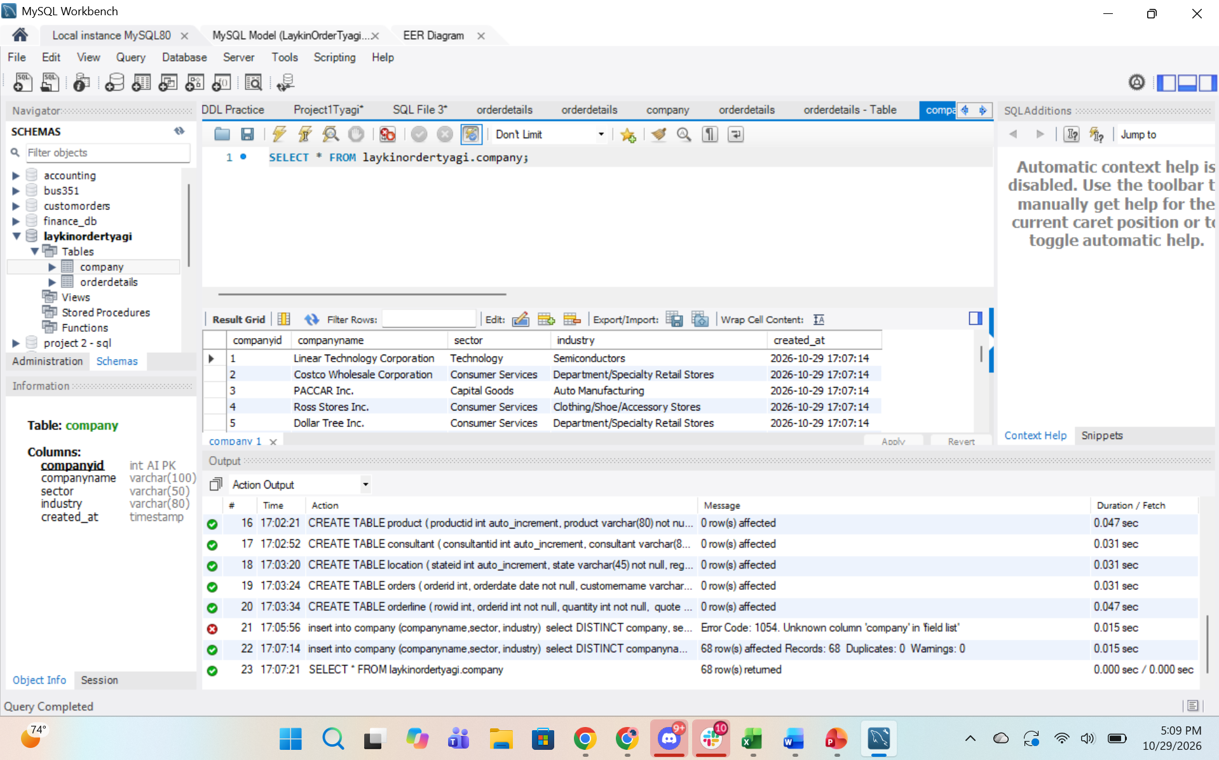

Product:
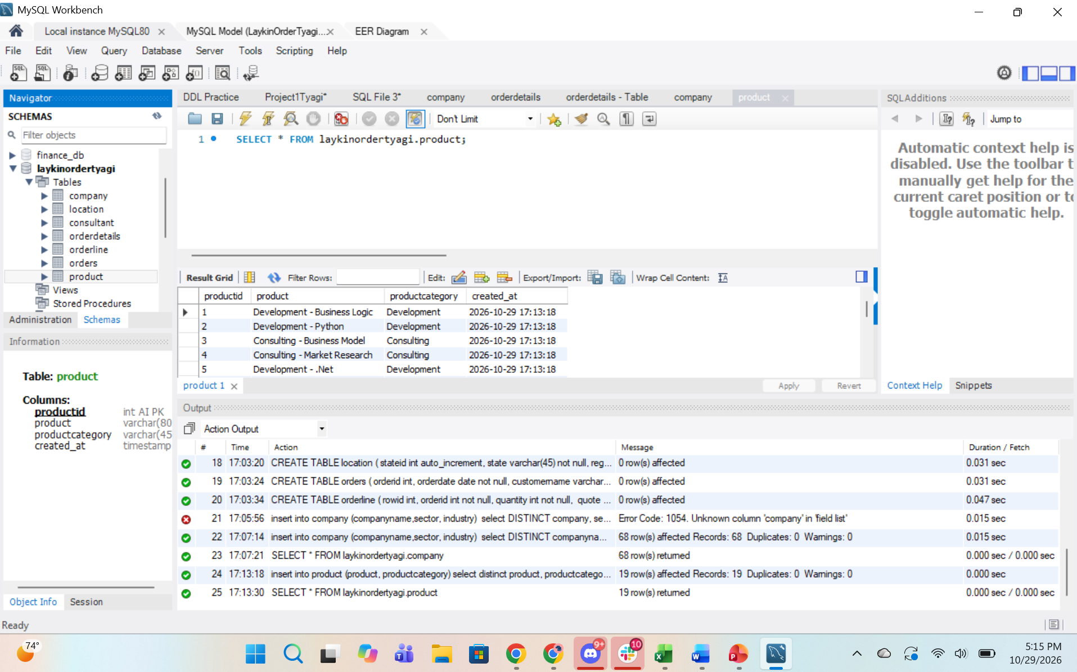

Consultant:
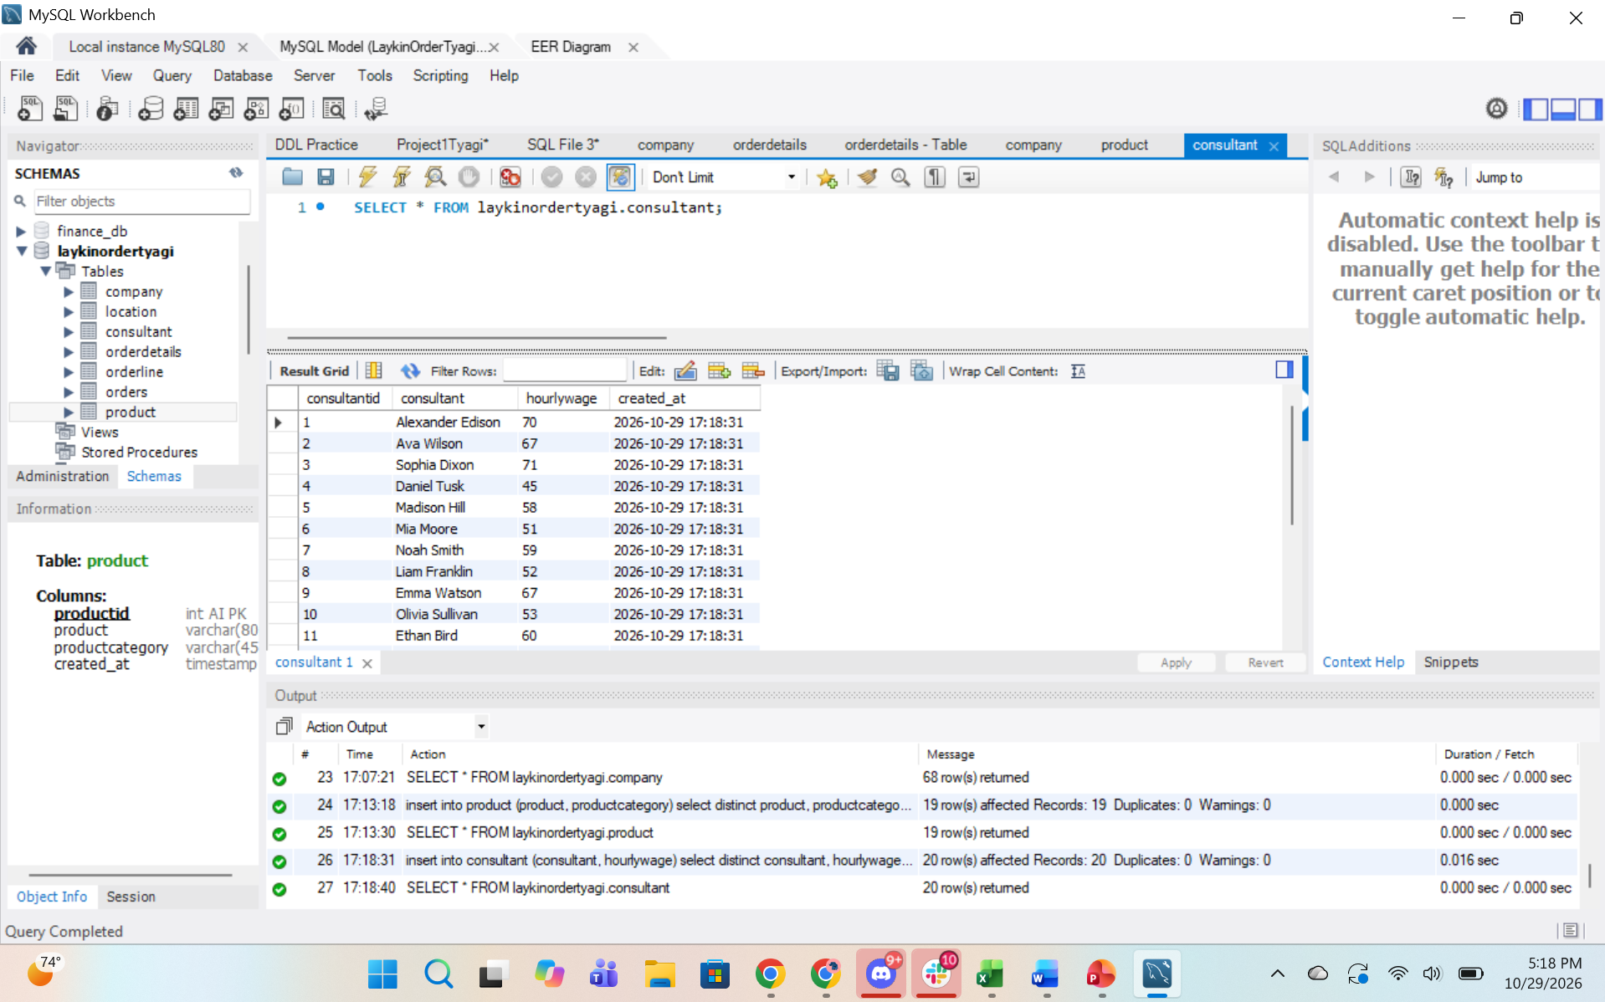
Location:
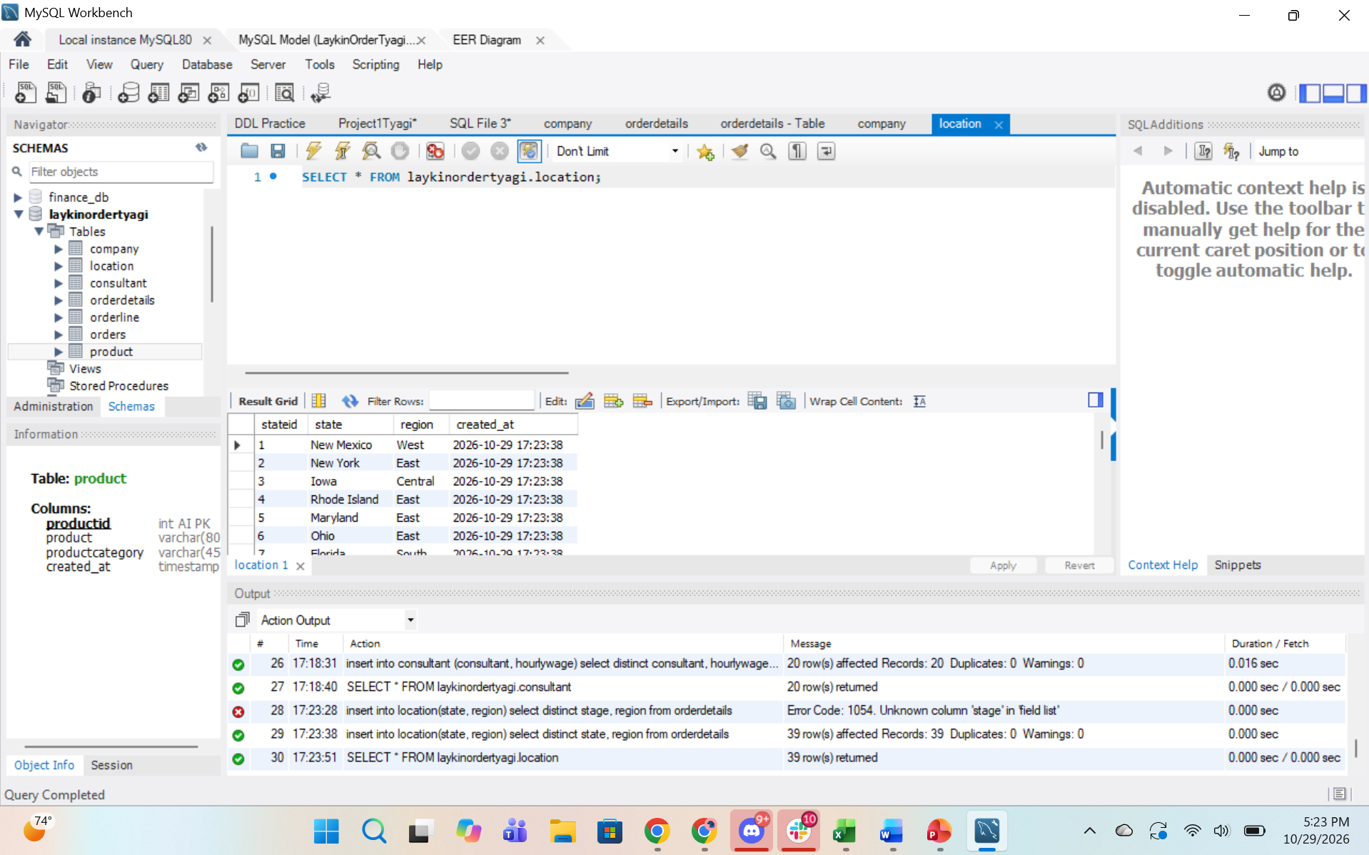

Orders:
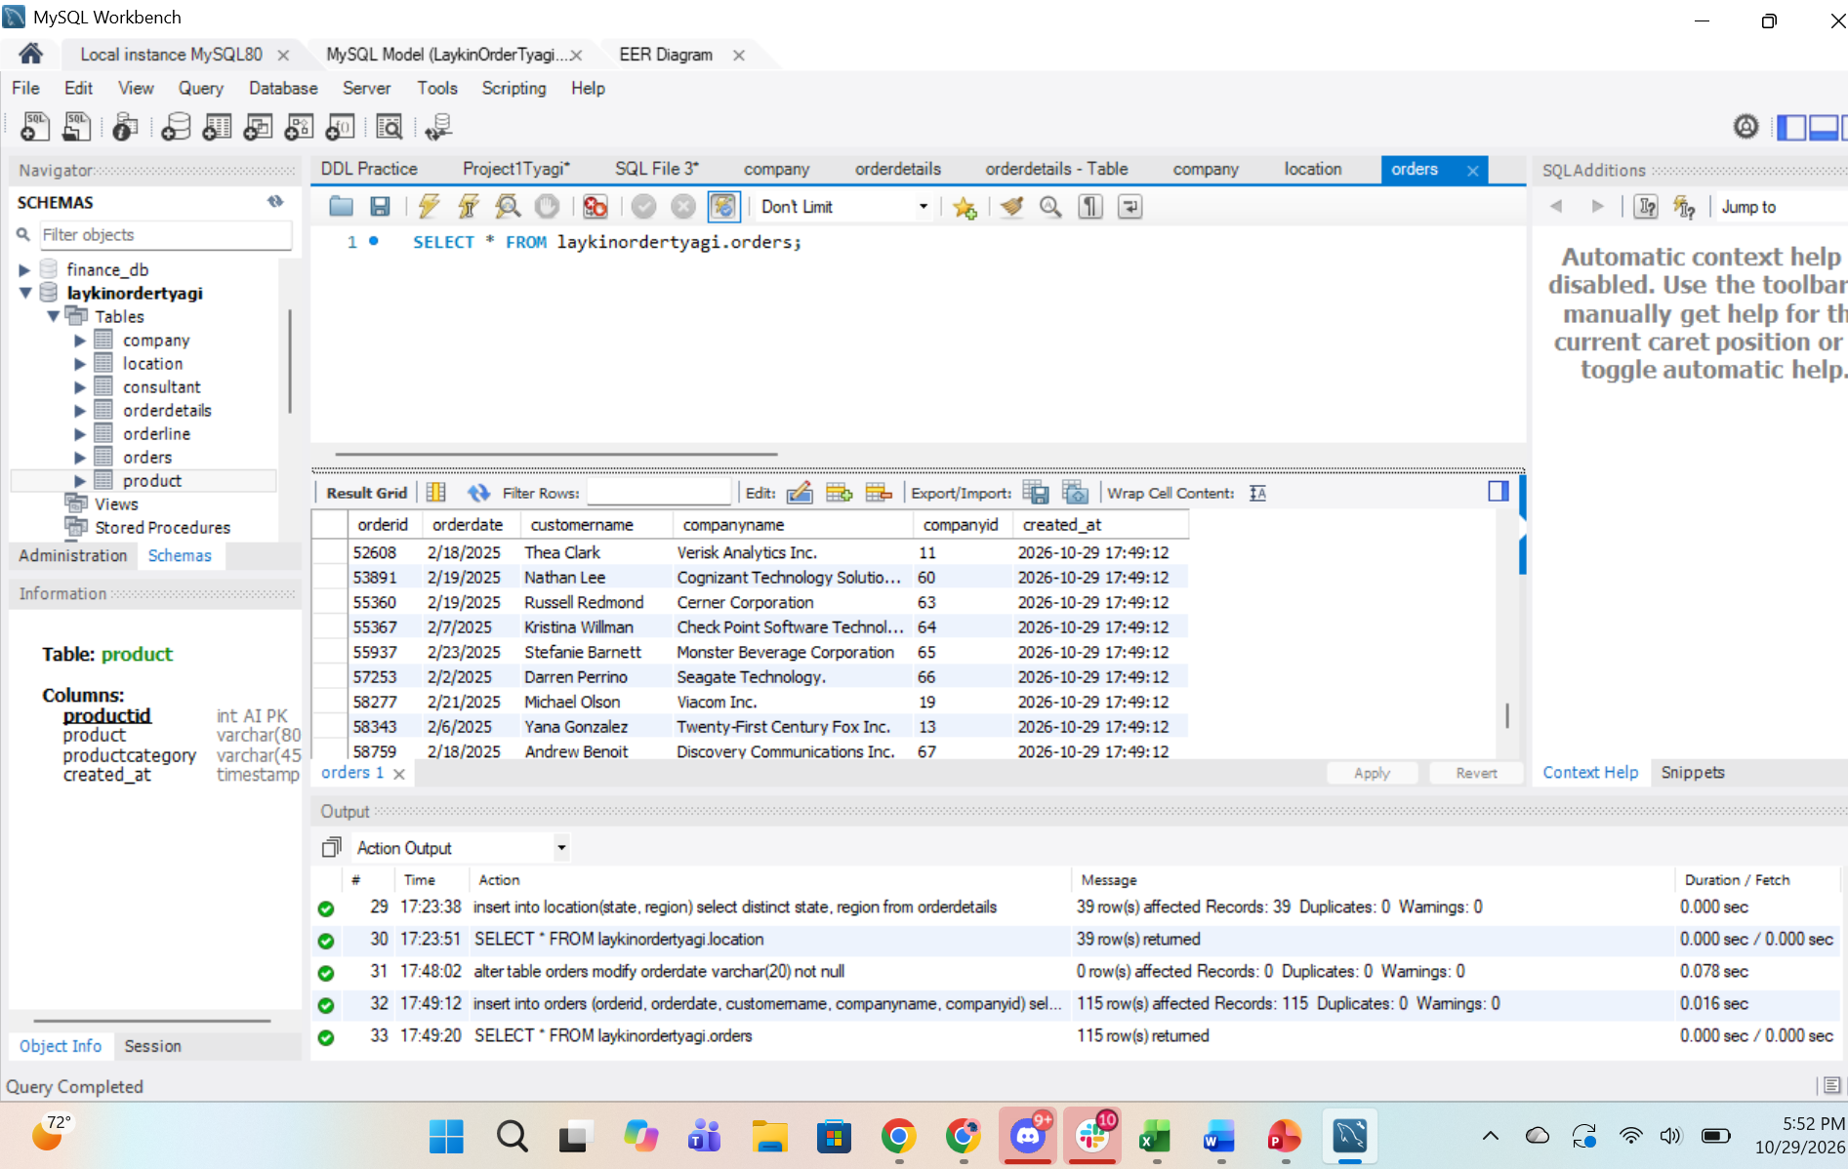
Orderline:
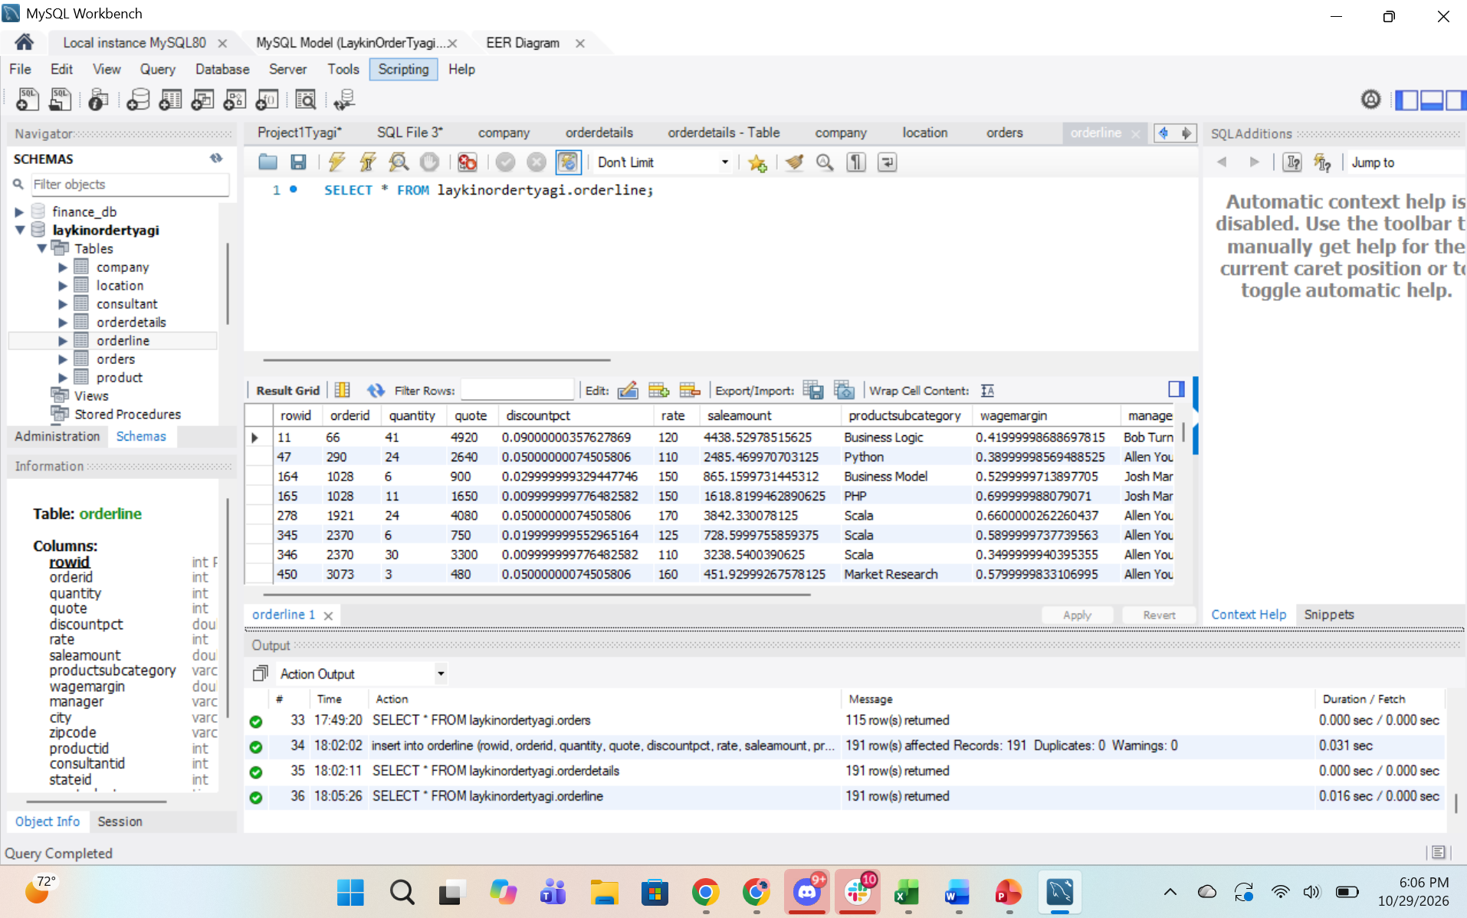

17. Write SQL code to answer the following questions. Screenshot your code and results for each.
- List the top company with their company name in terms of sales. Validate your code by creating a pivot table in Excel. Show screenshots of the code, code results, and pivot table below.
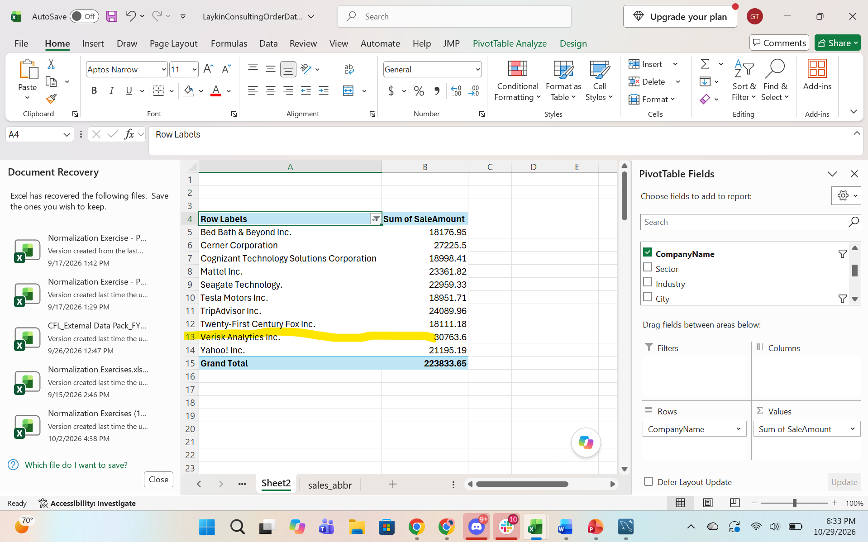
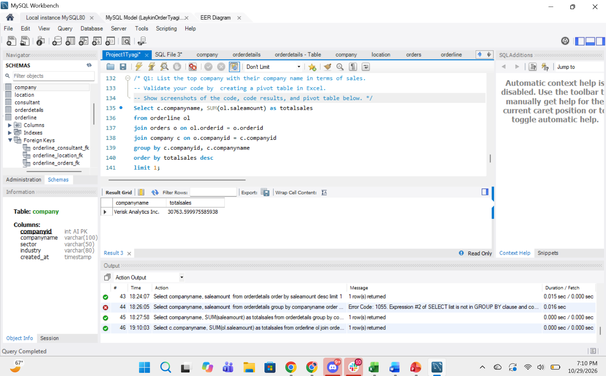

- Which sector has the lowest sales?
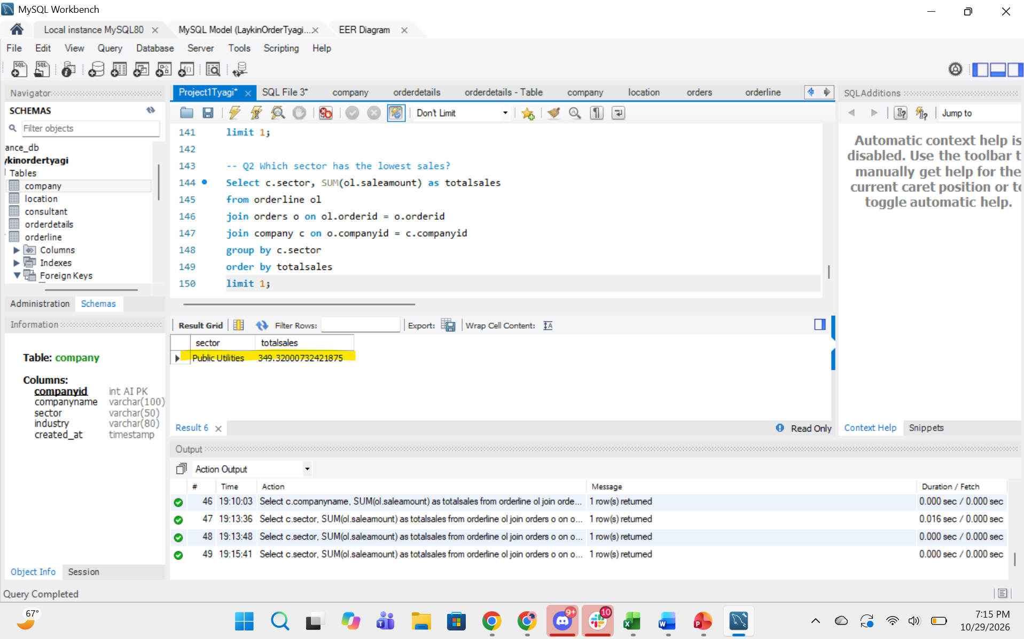
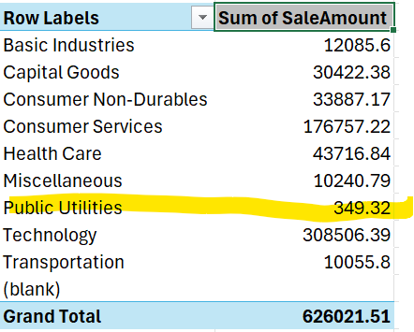
- Show the total sales by manager, with the highest ones showing first.
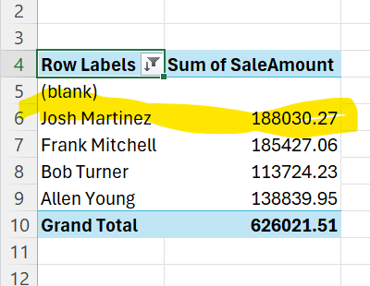

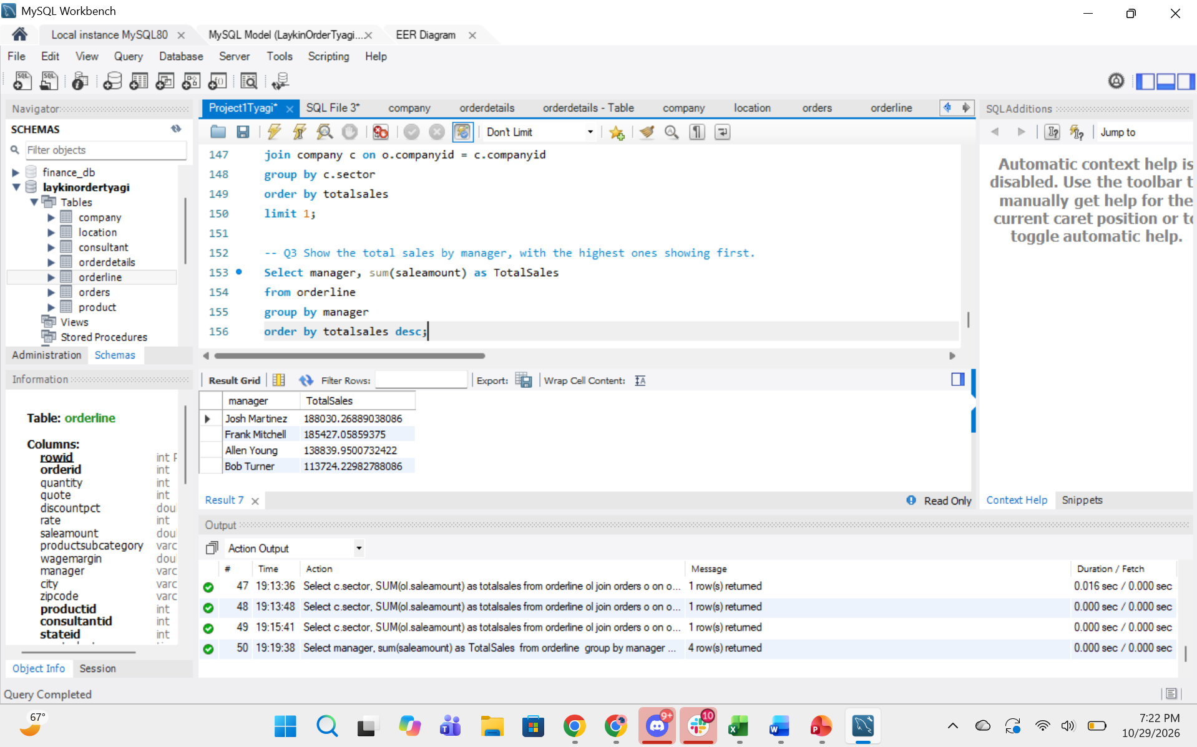
- Who are the ten best consultants in terms of sales? Show the hourly wage for each.
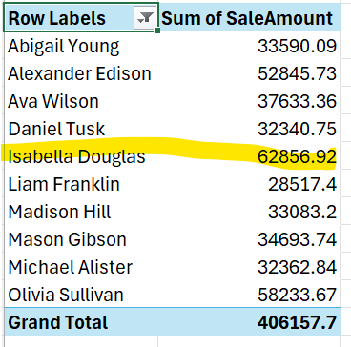
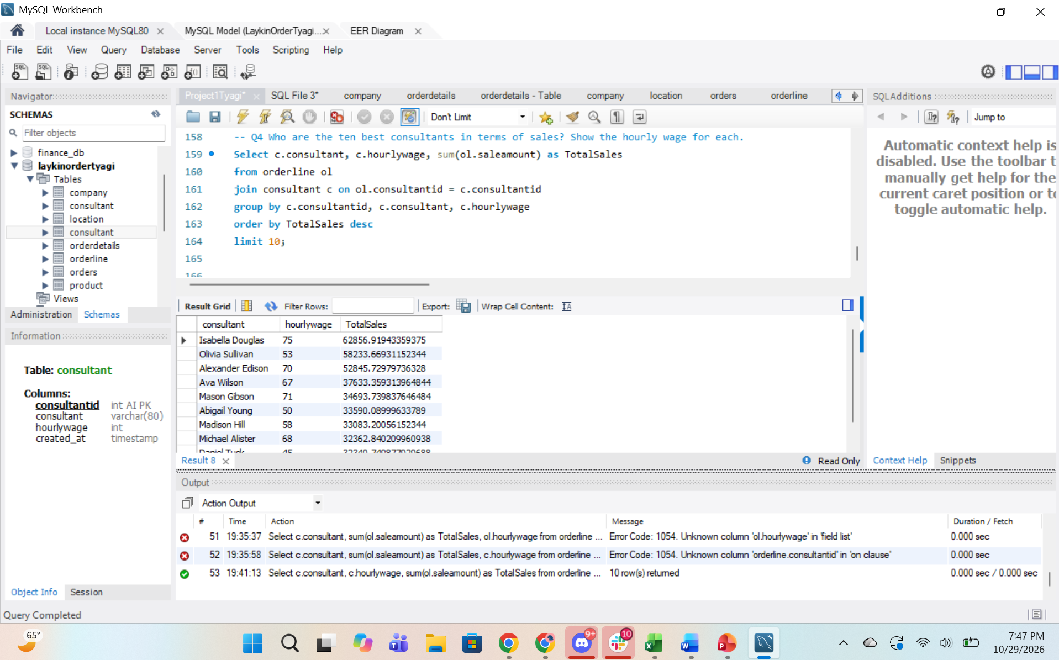
- Who are the customers with ordered products where the work is done to states with state names end in ee? Use REGEXP to filter the data.
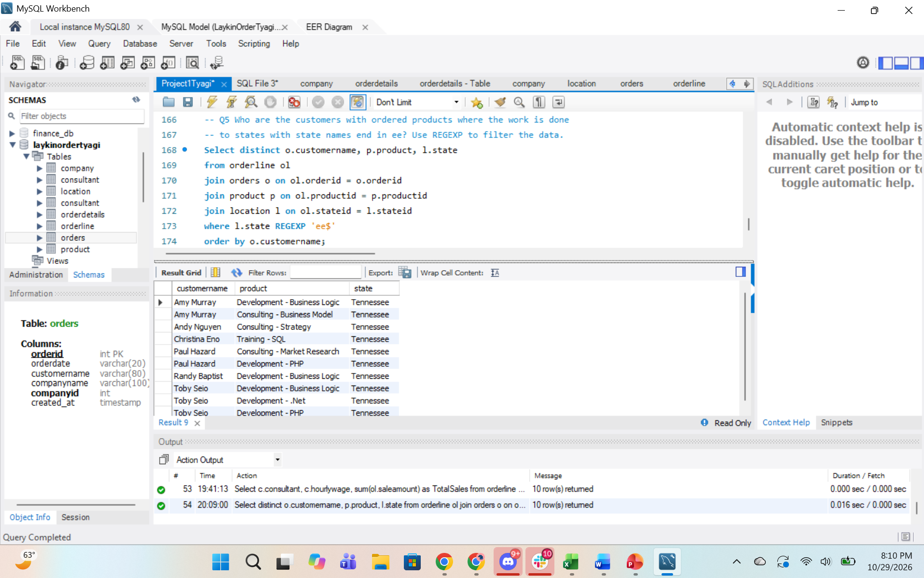
- Create one additional SQL program to answer a question not already asked. It must join three of the tables in your design.

Question: which orders that had a quantity of 40 or more were sold and by which consultant
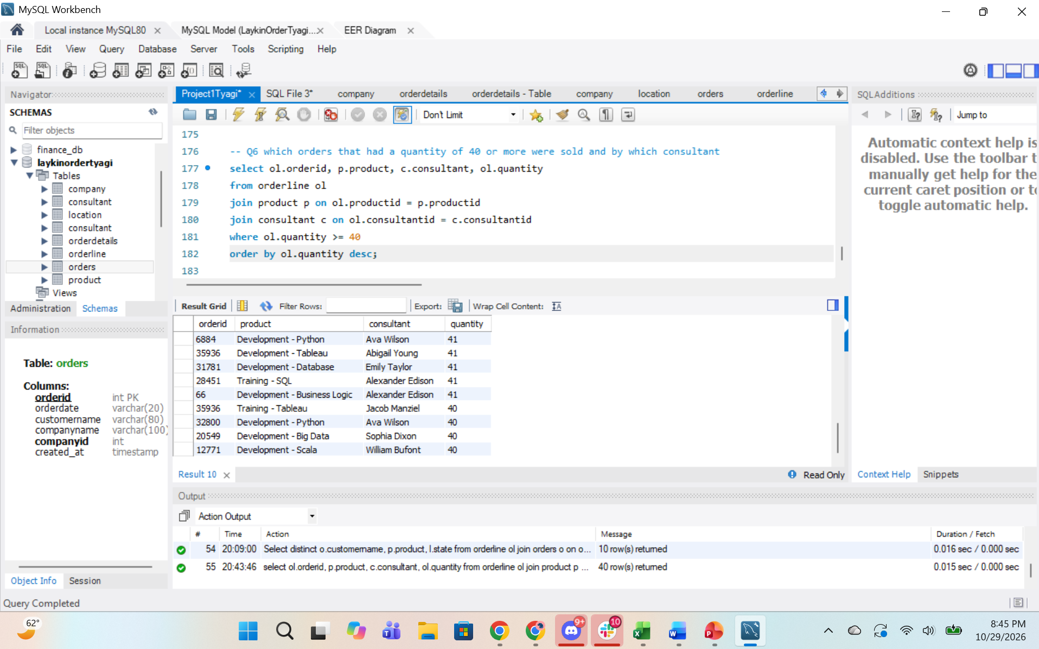

- Create one additional SQL program to answer a question not already asked. It must join at least two of the tables in your design and show aggregation.
Question: what are the total sales by region
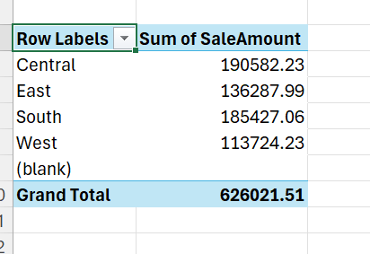
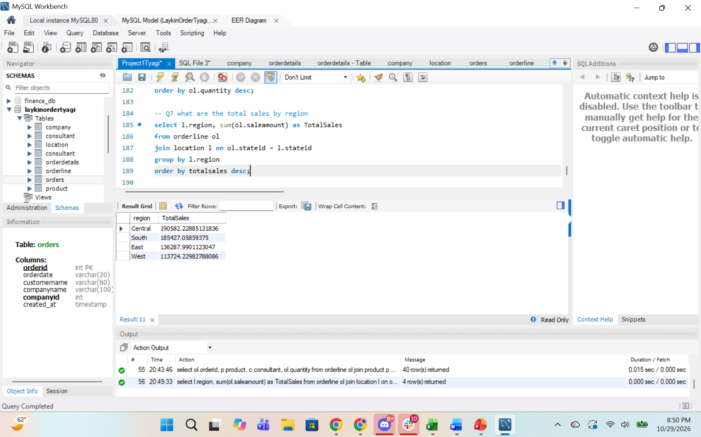
- Create one additional SQL program to answer a question not already asked. It must contain a subquery.
Question: which orderlines had a saleamount above the average
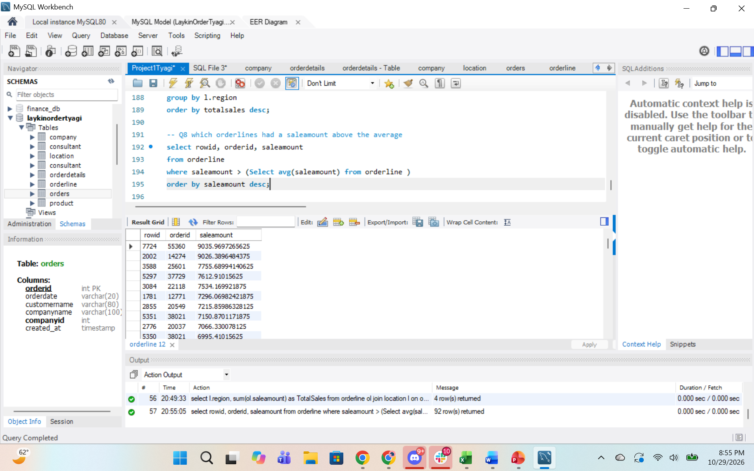
- Create one additional SQL program to answer a question not already asked. It must be filtered using the LIKE statement.
Question: Which products are training products
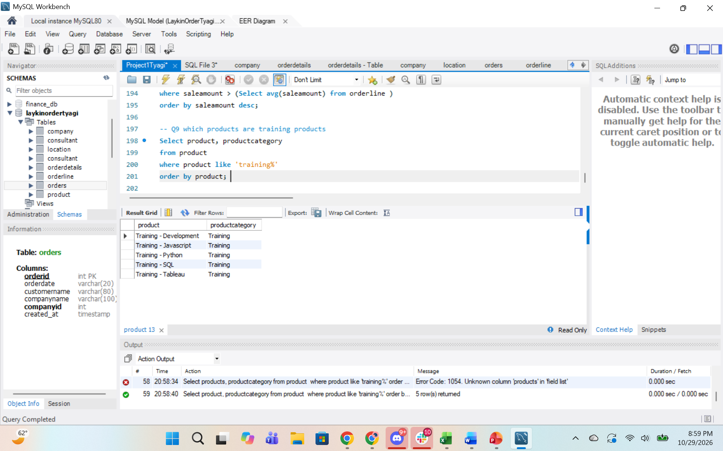
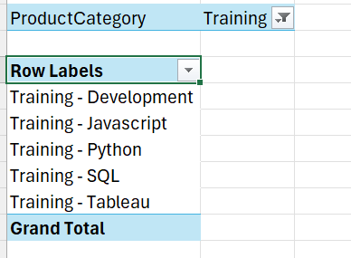
- Create and run one view of your choosing that you think a manager might need.
Question: Order Summary View
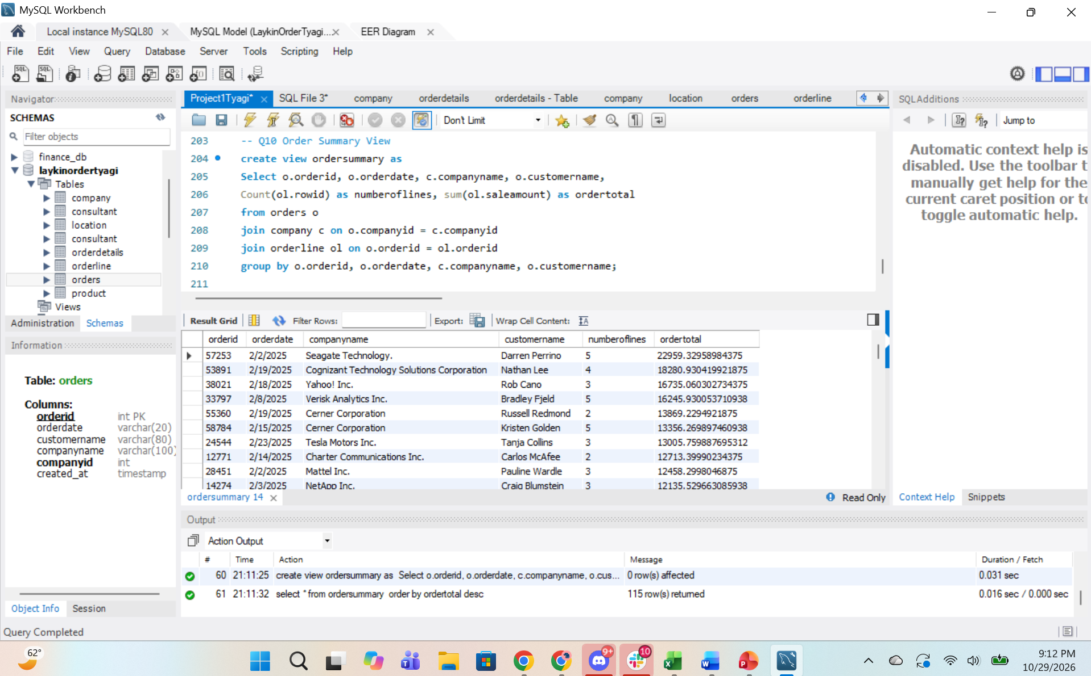
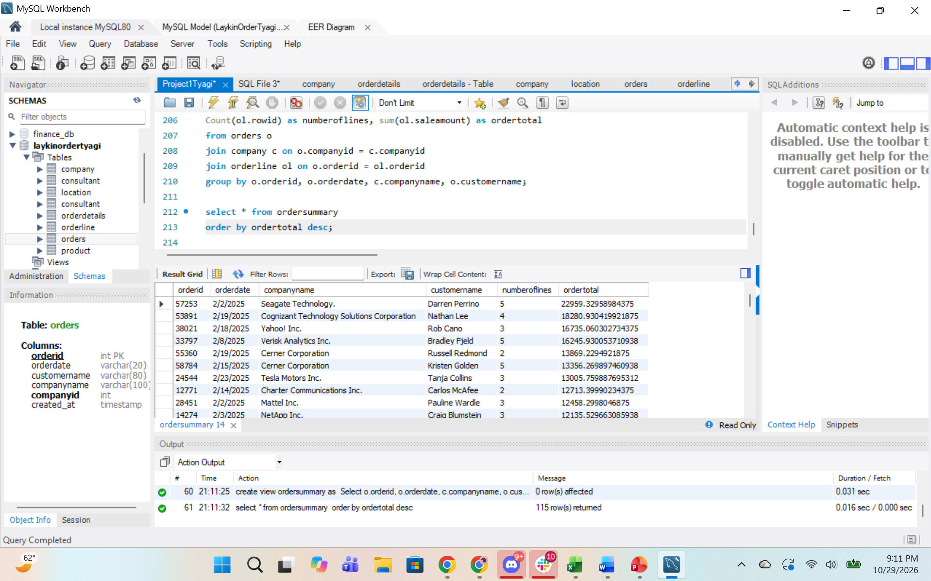
18. Submit the following to Moodle by the deadline:
- This word document (with screenshots for each task) (no pdfs);
- the .sql file.
- the .mwb file.

